MOBILE BASED PERSONAL FINANCE ASSISTANT TO MANAGE BUDGETS AND SAVINGS GOALS EFFECTIVELY.

BY
SHADRACK OTIENO IN16/00078/22
ALEX NDUNG’U IN16/00011/22

Contents
1.0 BACKGROUND INFORMATION 3
1.1 Problem Statement 6
1.2 Objectives 7
1.2.1 General Objective 7
1.2.2 Specific Objectives 7
1.3 Research questions 7
1.4 Hypothesis 7
1.5 Significance of the Study 8
1.6 Justification 9
1.7 Scope and Boundary 10
2.0 LITERATURE REVIEW 12
2.1 Introduction 12
2.2 Related work 12
2.3 Challenges of existing techniques 13
2.4 Gaps in Existing Research and Tools 14
3.0 METHODOLOGY 15
3.1 Introduction 15
3.2 Analysis and design tools 15
3.3 System Implementation Tools/Techniques 16
3.4 System Testing and Validation 17
4.0 SYSTEM ANALYSIS & DESIGN 23
4.1 System Analysis 23
4.2 Requirement Specification 23
4.2.1 Functional Requirements 23
4.2.2 Non-functional requirements 27
4.2.3 Hardware & Software Requirements 27
5.0 SYSTEM IMPLEMENTATION, TESTING & VALIDATION 28
5.1 System Design 28
5.2 Architectural Design 28
5.3 Interface Design 29
6.0 SUMMARY, CONCLUSIONS AND RECOMMENDATIONS 30
6.1 Summary 30
6.2 Conclusion 30
6.3 Recommendations 30
6.4 References 31

1.0 BACKGROUND INFORMATION

In recent years, the importance of personal financial management has become increasingly evident where economic fluctuations, high living costs, and income disparities have made it more challenging for individuals to maintain financial stability. As the cost of living rises, many people, particularly young adults and low-income earners, find it difficult to manage their budgets, save for future goals, or build a financial cushion for emergencies. These challenges are further compounded by the limited availability of financial education and resources. In response to these issues, there has been growing interest in leveraging mobile technology to offer personalized financial management tools that can help users create and track budgets, set savings goals, and make informed financial decisions. This project aims to develop a mobile-based personal finance assistant designed to address these needs by providing users with easy-to-use tools for managing their finances.
Kenya, for example has seen significant economic growth in recent years, but income inequality and poverty remain widespread challenges. According to the World Bank (2020), approximately 36% of Kenya’s population lives below the poverty line, making it difficult for many households to save or maintain a budget. Moreover, financial literacy in Kenya is relatively low, particularly among young adults, women, and rural populations. A study by the Financial Sector Deepening (FSD) Kenya (2019) found that only about 38% of Kenyans are considered financially literate, which means that a large portion of the population lacks the skills and knowledge needed to manage their finances effectively. Many individuals rely on informal savings mechanisms, such as savings groups, which can be unreliable and offer limited opportunities for growth.
This lack of financial literacy has contributed to high levels of debt and financial insecurity among Kenyans. The 2019 FinAccess Household Survey revealed that 16% of Kenyan households had at least one member with a formal loan, while 40% of respondents indicated they had experienced financial stress due to debt in the previous year. These statistics highlight the urgent need for financial education and accessible tools that can help individuals improve their financial management skills and work toward financial independence.
Kenya is often hailed as a global leader in mobile technology, particularly in mobile money services. The advent of mobile money platforms like M-Pesa has transformed the way Kenyans access financial services, with over 27 million users by 2020 (Communications Authority of Kenya, 2020). This widespread adoption of mobile technology has provided an ideal platform for the delivery of financial services, including mobile-based personal finance tools. As mobile phone penetration in Kenya continues to grow—reaching approximately 118% by 2020 (World Bank, 2020)—there is a unique opportunity to leverage this technology to promote financial literacy and improve personal financial management.
Mobile-based financial applications have the potential to reach a wide demographic, including underserved populations such as women, rural residents, and the youth. In a country where traditional banking infrastructure is limited, especially in rural areas, mobile phones provide a lifeline for individuals to access financial services. A study conducted by Suri and Jack (2016) found that access to mobile money has had a profound impact on poverty reduction in Kenya, particularly for female-headed households, who were able to increase savings and reduce their reliance on informal financial systems.
Given the ubiquity of mobile phones and the success of mobile money services, there is strong evidence to suggest that a mobile-based personal finance assistant could have a significant impact on improving personal financial management in Kenya. The proposed project will build on the existing mobile infrastructure to provide users with tools for creating and tracking budgets, setting savings goals, and making informed financial decisions. By offering these services through a mobile platform, the project aims to reach a wide audience, including those who may not have access to traditional financial services or financial education.
Personal finance applications have been widely recognized as an effective tool for promoting financial literacy and improving money management skills. A study by Hasler and Lusardi (2017) highlights the positive relationship between financial technology (fintech) applications and improved financial outcomes. These applications, particularly those accessible via mobile devices, offer a range of tools that allow users to track spending, set savings goals, and receive real-time updates on their financial progress. In Kenya, where many people have irregular incomes or face challenges in managing money due to cultural or economic factors, such applications could play a transformative role in improving financial stability.
The integration of budgeting and savings tools into a mobile app offers several key advantages for Kenyan users. First, it simplifies the process of tracking income and expenses, enabling users to monitor their financial habits more effectively. Second, it provides a structured approach to saving, allowing users to set both short-term and long-term savings goals. Third, it offers flexibility, enabling users to adjust their budgets and savings plans in response to changes in income or spending priorities. Given the dynamic nature of the Kenyan economy, where many people rely on informal employment and have fluctuating incomes, this flexibility is essential for effective financial management.
Several fintech startups in Kenya have already demonstrated the potential of mobile applications in promoting savings and budgeting. For instance, apps like Tala and Branch offer microloans and financial advice, helping users manage short-term financial needs. However, these platforms are often focused on credit rather than long-term financial planning. The proposed mobile-based personal finance assistant will go beyond providing access to credit by focusing on financial education, budgeting, and savings, offering a holistic solution that promotes financial independence rather than debt reliance.
Despite the growing availability of financial services in Kenya, there remains a significant gap in financial literacy, particularly in rural areas and among marginalized populations. As noted by Munene and Mutegi (2019), there are limited formal programs aimed at improving financial literacy in the country, and many Kenyans continue to rely on informal savings mechanisms. This gap presents a critical challenge, as financial literacy is essential for making informed financial decisions, avoiding debt, and achieving long-term financial goals.
By developing a mobile-based personal finance assistant, this project aims to address this gap by providing users with educational tools and resources that promote financial literacy. Through the app, users will have access to financial tips, budgeting templates, and savings calculators that help them make informed decisions about their money. The app will also send users regular updates on their financial progress, encouraging them to stay on track with their savings goals and adjust their budgets as needed. This combination of education and practical tools will empower users to take control of their finances and work toward financial stability.
The need for improved financial literacy and accessible financial management tools in Kenya is evident. The proposed mobile-based personal finance assistant seeks to address these needs by leveraging Kenya's mobile technology infrastructure to provide users with tools for budgeting, saving, and financial education. By targeting underserved populations and promoting financial independence, the project has the potential to improve the financial well-being of millions of Kenyans. The success of mobile money platforms like M-Pesa demonstrates that mobile technology can have a profound impact on financial inclusion, and this project builds on that legacy by focusing on personal financial management. Ultimately, the study aims to contribute to a more financially literate and economically stable society in Kenya.

1.1 Problem Statement
Managing personal finances can be a complex and time-consuming task for individuals, especially when it comes to tracking expenses, setting budgets, and maintaining financial discipline. Many people struggle with understanding their real-time financial standing, leading to unintentional overspending and mismanagement of available resources. With income and expenses coming from multiple sources like bank accounts, credit cards, and loans, it becomes difficult to consolidate all this data in a meaningful way. This fragmentation makes it challenging for users to have a clear, comprehensive view of their financial health, which is crucial for making informed financial decisions.
Another major challenge faced by users is the ability to set and stick to realistic savings goals. While many understand the importance of saving, there is often a lack of structured guidance on how to allocate funds toward different financial objectives, whether short-term or long-term. Without the right tools to track progress toward these goals, users may feel demotivated and lose track of their savings milestones, resulting in inconsistent financial growth. Furthermore, the overwhelming amount of financial data can make it hard to visualize patterns in spending, making it difficult for individuals to identify areas where they can cut costs and save more effectively.
In addition, a lot of existing financial tools are either too complicated or lack the personalization needed to cater to individual needs. Each person has unique spending habits, income levels, and financial priorities, and generic solutions often fail to address these differences. There is a need for a personalized finance assistant that not only helps users manage their day-to-day budget but also adapts to their changing financial needs over time. This tool should offer intuitive tracking, clear goal-setting features, and personalized financial insights to empower users to take control of their financial well-being effectively.

1.2 Objectives

1.2.1 General Objective
To design and implement a smart financial management system that leverages artificial intelligence to guide users in creating budgets, monitoring expenses, and accomplishing personalized savings goals with greater accuracy and efficiency.
1.2.2 Specific Objectives
1. To design a budget management system that offers easy-to-use tools that enable users to set up, adjust, and track monthly budgets according to their income and spending needs.
2. To establish personalized savings goal setting by allowing users to create and track short-term and long-term savings objectives, ensuring progress through regular updates.
3. To come up with a flexible budget adjustment system that allows users to modify their budget allocations in real-time as their income or spending priorities change.

1.3 Research questions
- How can financial literacy tools be integrated into a mobile app to effectively help users manage their budgets and savings goals?
- What are the most effective methods for enabling users to set and track personalized savings goals through a mobile app?
- How can a mobile app simplify budget management for users with varying levels of financial expertise?
- What is the most efficient way to implement real-time budget adjustments in a mobile app, allowing users to modify allocations based on income and changing spending priorities?

1.4 Hypothesis
The hypothesis for the research is that a mobile application will substantially improve users' financial management capabilities by providing real-time tracking, personalized budgeting suggestions, and automated financial insights. The assistant will help users make more informed financial decisions by analysing their spending patterns, income, and savings behaviour.

1.5 Significance of the Study
The study on a Mobile-Based Personal Finance Assistant is of profound importance in today’s rapidly evolving digital and financial landscape. As personal finance becomes increasingly complex, with numerous income streams, expenditures, and savings goals, individuals often struggle to manage their finances effectively. This project aims to address these challenges by providing users with a comprehensive, user-friendly solution to managing budgets and savings goals directly from their mobile devices. The significance of this study can be understood from several key perspectives: financial literacy, technological innovation, and social impact.
Firstly, enhancing financial literacy is crucial for individuals to achieve financial independence and stability. The mobile application developed from this study will integrate educational components that help users understand budgeting, savings, and financial goal-setting. By promoting financial literacy, the study will empower users to make informed decisions about their money, helping them avoid debt, manage expenses, and set achievable financial goals. This contribution is especially important for young adults, low-income individuals, or those with limited financial knowledge, as they often face the most significant barriers to managing their finances effectively.
Secondly, the project will demonstrate the innovative use of mobile technology in addressing personal finance management issues. With the increasing penetration of smartphones globally, mobile applications have become a preferred medium for delivering services, and the personal finance sector is no exception. The study will explore how technology can simplify complex financial processes, making budgeting, savings tracking, and goal setting more accessible to a broader audience. The mobile platform ensures that users can track their financial progress on the go, adjust budgets in real-time, and receive regular updates on their savings goals, thereby creating a more dynamic and responsive personal finance experience.
Lastly, this study has a significant social impact. In a world where financial inequality is growing, providing individuals with tools to manage their finances effectively can help reduce the wealth gap and promote economic inclusivity. The mobile-based personal finance assistant empowers users by giving them control over their financial future. By enabling people to better manage their money, the study contributes to improving their overall quality of life, reducing financial stress, and fostering a culture of responsible spending and saving.

1.6 Justification
The research titled "Mobile-Based Personal Finance Assistant to Help Users Manage Their Budgets and Savings Goals Effectively" is justified by the urgent need for improved personal finance management tools in an increasingly complex financial landscape. With growing financial responsibilities such as managing day-to-day expenses, debt repayments, and long-term savings, many individuals find it difficult to keep track of their financial activities and set realistic goals. Poor financial management often results in overspending, lack of savings, and financial stress, making it critical to provide people with a practical, accessible tool to enhance their financial well-being.
Mobile technology offers an excellent platform for delivering such a solution. Smartphones are ubiquitous, and most people use them for various aspects of their lives, including communication, work, and entertainment. By leveraging this widespread access, a mobile-based finance assistant can ensure that users have their financial data and management tools at their fingertips, enabling them to monitor their budgets and track their progress in real-time, no matter where they are. The convenience of mobile technology ensures that users can engage with their finances more regularly and consistently, improving their financial habits over time.
The application’s functionalities, such as real-time tracking of expenses, automatic categorization of spending, goal-setting, and progress visualization, are designed to help users make more informed financial decisions. Users can set personalized savings goals and receive notifications or alerts when they are close to exceeding their budget or when they’ve reached important financial milestones. This level of interactivity keeps users engaged with their financial planning and encourages greater discipline in budgeting and saving. Furthermore, by offering simple, user-friendly interfaces, the finance assistant reduces the complexity often associated with traditional budgeting methods, making financial management more approachable for users who may not have prior financial expertise.
In addition to the practical benefits for individual users, the research is justified by the broader social and economic impact that improved financial management can have. Financial stress is a major contributor to poor mental health, and by empowering individuals to take control of their finances, this mobile-based solution could help reduce anxiety related to money management. Improved personal financial health also has a positive ripple effect on the economy, as individuals who are more financially secure are more likely to contribute to savings, investments, and overall economic stability.
The increasing trend toward digital solutions for personal finance management further justifies this research. As digital transformation continues to reshape industries, financial services are no exception. More people are seeking digital tools to manage their money, and a mobile-based finance assistant would not only meet this demand but also help bridge the gap for those who are less experienced with traditional financial planning. By providing an intuitive, portable platform, the app would enable users from diverse backgrounds to participate more actively in managing their financial well-being.
In conclusion, the justification for this research lies in the pressing need for accessible, efficient, and user-friendly financial management tools. With mobile technology as a powerful platform, the proposed personal finance assistant can help users overcome the challenges of budgeting and saving in an increasingly digital and fast-paced world. By making financial management more convenient, personalized, and effective, this research has the potential to significantly improve users' financial habits, reduce financial stress, and promote long-term financial stability.

1.7 Scope and Boundary
The scope of this project is to develop a Mobile-Based Personal Finance Assistant designed to help users effectively manage their budgets and savings goals. The project focuses on building a user-friendly mobile application that offers tools for financial literacy, personalized goal setting, budget tracking, and real-time financial adjustments. Key functionalities will include budget creation and management, the ability to set and monitor both short-term and long-term savings objectives, and alerts or notifications to help users stay on track with their financial plans.
The application will cater to a broad range of users, from individuals with minimal financial expertise to those more experienced in managing personal finances. It will primarily focus on helping users manage day-to-day expenses and allocate savings according to their goals. The app will integrate features like expense categorization, savings progress tracking, and basic financial reports, making it accessible and practical for people across various income levels and financial situations. Additionally, the application will allow real-time updates, giving users flexibility in adjusting their budgets based on changes in income or expenses.
The boundaries of the project exclude complex financial tools such as investment tracking, credit management, or advanced tax calculations, which are outside the primary scope of basic budgeting and savings. Furthermore, the app will be designed for personal financial management, not for businesses or corporations. The project will not include integrations with financial institutions for direct banking or investment purposes but may allow manual entry of data related to financial transactions

2.0 LITERATURE REVIEW

2.1 Introduction
Personal finance management has evolved significantly in the last decade with the rise of mobile technology. The demand for user-friendly tools that assist individuals in managing their finances, tracking expenses, and achieving savings goals has driven the growth of mobile finance applications. This literature review explores recent studies that examine the impact of mobile-based financial tools on personal finance management, their effectiveness in influencing user behaviour, and the gaps that remain in current solutions. By reviewing this literature, the groundwork is laid for developing an enhanced mobile-based personal finance assistant that can better cater to the needs of users.
Before the widespread use of mobile apps, traditional methods of personal finance management included manual tracking and desktop-based financial software. However, these approaches were time-consuming and often lacked real-time insights, which limited their utility. Recent studies show that digital transformation, particularly through mobile finance applications, has radically changed how people manage their finances . Mobile applications have become essential tools for daily financial management, offering automated tracking, budget planning, and real-time notifications. According to a report by Statista (2019), the use of finance apps has grown exponentially in recent years, driven by the increased penetration of smartphones and the demand for efficient financial solutions.
However, despite the availability of mobile finance tools, many individuals still struggle with maintaining financial discipline. A study by Thomas and Mainelli (2020) revealed that even with access to digital tools, 65% of users reported challenges in sticking to their budgets and controlling impulse spending. These challenges point to the need for more personalized and engaging tools that cater to individual financial habits, rather than generic budgeting solutions.

2.2 Related work
The last five years have seen significant advancements in mobile finance applications. Apps like Mint, YNAB (You Need a Budget), and EveryDollar offer features like automated budget tracking, savings goal setting, and real-time notifications. These apps help users stay aware of their spending patterns and provide a more structured approach to managing personal finances. Research by ( Kim et al. 2020) shows that mobile finance apps can increase financial awareness, with users reporting improved financial behavior after just a few months of app usage.

However, some studies have noted limitations in the user experience of current apps. While Mint, for example, is known for providing a comprehensive view of a user’s finances, research by (Wang et.al..2019) found that its complexity and extensive features can overwhelm users, leading to app abandonment after a few months. Additionally, many apps focus on short-term financial goals such as daily budgeting but offer limited support for long-term financial planning, such as retirement savings or investment strategies.
Several studies have investigated the impact of mobile apps on user financial behavior. Research by Fernandez et al. (2018) found that users of mobile finance apps are more likely to adopt positive financial habits, such as regularly tracking expenses and setting financial goals. These apps provide users with visual feedback, making it easier to understand spending trends and identify areas for improvement. This aligns with behavioral economics theories, which suggest that immediate feedback can help users correct course and form better habits (Thaler & Sunstein, 2017).

2.3 Challenges of existing techniques
Despite these positive outcomes, there are challenges to maintaining long-term engagement with finance apps. Research by Miller et al. (2021) highlights the issue of “app fatigue,” where users stop engaging with the app after initial enthusiasm wanes. The study found that over 50% of users abandoned finance apps within three months, citing reasons such as lack of motivation, complexity, or overwhelming notifications. This suggests that while mobile finance apps can be powerful tools for improving financial behavior, they must be designed in a way that ensures continued user engagement over the long term.
The relationship between financial literacy and the use of mobile finance tools has been a major focus of recent research. Financial literacy is a crucial factor in how effectively users engage with personal finance apps. Studies by Lusardi and Mitchell (2019) have shown that individuals with low financial literacy often struggle to utilize mobile finance apps to their full potential. Even though these apps are designed to simplify financial management, users with limited knowledge of basic financial principles may find them challenging to navigate.
To address this, some apps have integrated educational features that aim to improve financial literacy while helping users manage their money. Apps like PocketGuard and GoodBudget offer tutorials, tips, and explanations of financial concepts (Kim & Choi, 2020). However, Miller et al. (2020) found that these educational features are often underutilized, as many users prioritize tracking expenses over learning new financial skills. The study suggests that a more integrated approach, where financial education is seamlessly incorporated into app functionalities, may enhance user engagement and financial literacy over time.

2.4 Gaps in Existing Research and Tools
Although mobile finance apps have become widely adopted, several gaps remain in current solutions. One major gap is the lack of personalization in many apps. Research by Tsai and Wang (2020) notes that while current finance apps offer general budgeting and savings features, they often fail to provide tailored advice based on individual financial situations. Personalization could significantly enhance the user experience by offering recommendations that align with a user’s specific income, spending habits, and financial goals.
Another gap is the limited focus on long-term financial planning. Many existing apps are designed to help users manage daily expenses, but they offer little guidance on more complex financial decisions, such as retirement planning, investment strategies, or debt management (Liu et al., 2021). This limitation restricts the utility of these apps for users who seek comprehensive financial management tools.
Furthermore, there is a need for research on user engagement and retention in mobile finance apps. While many studies focus on short-term usage patterns, fewer studies explore how to keep users engaged with these tools over time. As noted earlier, app abandonment remains a major issue (Miller et al., 2021), and addressing this problem will require a deeper understanding of user motivations and behaviour.

3.0 METHODOLOGY

3.1 Introduction
This study adopts a mixed-methods approach to evaluate the effectiveness of a mobile-based personal finance assistant in helping users manage their budgets and achieve savings goals. By combining quantitative and qualitative research methods, the study will provide a comprehensive view of both measurable financial behaviors and users’ personal experiences with finance management tools. Quantitative data will be collected through surveys and app usage metrics, offering insights into budgeting habits, savings outcomes, and app engagement. At the same time, qualitative data will be gathered through interviews and focus groups to explore users' challenges, preferences, and expectations regarding financial management apps.
To ensure relevance and inclusivity, the study will target a diverse group of participants from different income levels, financial literacy backgrounds, and geographical locations in Kenya. Data analysis will involve statistical techniques for quantitative data and thematic analysis for qualitative responses, allowing for a deeper understanding of how the app impacts users' financial management. Additionally, usability testing will be conducted to evaluate the app's interface and features, with ethical guidelines followed to protect participant privacy and ensure informed consent throughout the research process.

3.2 Analysis and design tools
Data collection
Data collection & Questions | Objective
1. User Surveys  How do you currently track your income and expenses (manually, spreadsheets, apps, etc.)?  What challenges do you face in sticking to your budget?  What features would you like to see in a personal finance app to help with your savings goals?  How often do you review your financial goals (weekly, monthly, quarterly)? | Understand users' current financial management practices and desired features in a budgeting tool.
2. Interviews and Focus Groups  Can you describe your typical budgeting process and what works well or doesn’t work?  What’s your biggest struggle when it comes to managing your savings goals?  How would a mobile app make budgeting easier for you, based on your current challenges?  What types of notifications or reminders would you find helpful for managing your finances? | Gain a deeper understanding of user pain points and expectations for features like reminders and savings tools.

3.3 System Implementation Tools/Techniques
The system is implemented using a combination of modern development tools and technologies to ensure scalability, reliability, and ease of use. The following tools and techniques are employed:
Development Platform
Flutter is used as the primary framework for cross-platform mobile development. Flutter allows the application to be developed once and deployed on both Android and iOS devices, ensuring a consistent user experience across platforms.
Dart is used as the programming language for writing the application’s logic, due to its seamless integration with Flutter and efficient handling of mobile-specific tasks.
Version Control
Git is used for version control to manage code changes, collaborate with team members, and maintain a history of the project’s development. This ensures that any changes or updates can be tracked and reverted if necessary.

3.4 System Testing and Validation
The system will undergo thorough testing and validation to ensure it meets the required functionality, is user-friendly, and performs optimally across different devices and environments.
Testing Methodologies
Various testing methods will be employed to ensure the quality and reliability of the system:
Unit Testing: Unit tests will be written to test individual components of the system, such as the budget calculation module, savings tracker, and authentication system. This ensures that each component works as expected in isolation.
Integration Testing: Integration testing will be performed to ensure that different components of the system (frontend, backend, and database) work together correctly. This includes testing the data flow between the mobile app and the database.
Usability Testing: Usability tests will be conducted with a group of users to evaluate the app’s ease of use, navigation, and overall user experience. Participants will complete tasks such as setting a budget or tracking expenses, and their feedback will be used to improve the user interface and design.
Functional Testing: Functional testing will validate whether the system meets its functional requirements, such as allowing users to create budgets, view expense reports, and manage savings goals.
Performance Testing: Performance tests will assess the system’s ability to handle multiple users and large amounts of data without significant delays or crashes. Stress tests will be performed to determine the app's performance under heavy usage conditions.
Security Testing: Security tests will be conducted to ensure that user data is protected from unauthorized access. This includes testing for vulnerabilities such as data breaches, SQL injection, and secure authentication mechanisms.

Validation Process
After testing, the system will undergo a validation process to ensure it meets the specified requirements and user expectations. This will involve:
User Feedback: Feedback from usability tests and focus groups will be gathered to ensure the app meets users’ needs and preferences.
Requirement Validation: The system will be compared against the initial requirements to confirm that all necessary features and functions have been implemented correctly.
Bug Fixes and Refinements: Based on testing results and feedback, any bugs or issues will be addressed, and the system will be refined before its final deployment.
This methodology provides a structured plan for developing, testing, and validating the mobile-based personal finance assistant, ensuring a high-quality, functional, and user-friendly application.

START
Welcome to the Personal Finance Assistant App
Is User New ?
Sign Up
Sign In
Username, Email, Password
Email, password
Validate
Registration successful, please log in
Store
Is Credentials Valid ?
YES
NO
YES
NO
Login successful
Set up your financial profile
monthly income, regular expenses, savings goals
Store
Profile setup complete

Create your monthly budget

Store Input
User Input

Budget Created Successfully

Enter your daily Expense

Store Input
User Input

Update Expenses
Expenses updated Successfully

View current Budget SRETRIEVE: - Total budget - Spent amount per category - Remaining budget per categorytatus

RETRIEVE
Total budget
Spent amount
Remaining budget per category
Budget Overview

Adjust Budget?
YesCV
Store update
Adjust budget

Budget Adjusted Successfully
No
RETRIEVE
Savings goal amount
Saved amount so far
Target date
Track Your savings Progress

CALCULATE savings progress as a percentage
Progress in percentage

YesCV
Update Savings
Adjust Saving Goal

No
Store Updates

WHILE app is running DO
Savings goal updated successfully

Is spendings Exceeding Budget?
Yes
SEND notification
You have exceeded your budget

No
Is savings goal deadline near?
Yes
SEND notification
Your savings goal is approaching, review your progress

No
Has user logged Expenses in X days?
SEND notification
Reminder: Log your expenses for [today's date]"
Yes
No

Generate financial report
RETRIEVE all budget, expenses, and savings data

GENERATE report showing:
Total income
Total expenses
Savings progress
Spending breakdown by category (graphs)
financial report to user

Log Out?
Yes
Close Session

No
Navigate Pages

END

4.0 SYSTEM ANALYSIS & DESIGN

In this chapter, we meticulously analyze and design the blueprint for our personal finance assistant app, ensuring it serves as a robust tool for helping users effectively manage their budgets and savings goals in the dynamic landscape of personal finance.

4.1 System Analysis
Our system analysis explores current personal finance tools, identifies gaps, and assesses user needs. This approach refines our app to empower users in budgeting, expense tracking, and savings, supporting informed financial decisions.

4.2 Requirement Specification
In outlining what our system needs, we clearly define the functional requirements and non-functional requirements to guide its development.

4.2.1 Functional Requirements

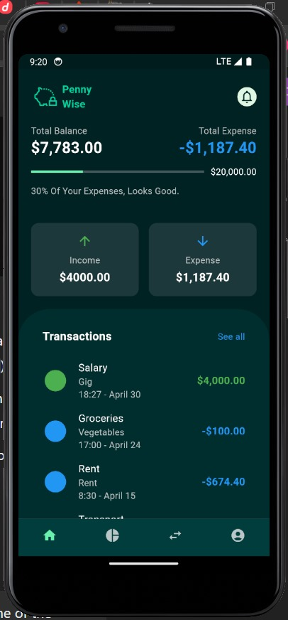
Financial Overview Display
The system will provide users with a comprehensive overview of their finances, displaying their total income, expenses, and current balance. This summary helps users understand their financial status at any moment, enabling better spending and saving decisions.

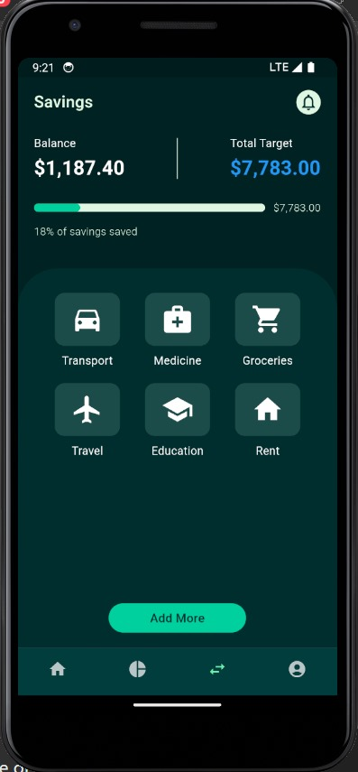
Savings Tracking and Goal Progress
Users will have the ability to track their savings, assign names to different savings goals, and monitor their progress through a visual progress bar. This feature supports personalized savings goals and provides motivation by clearly showing progress over time.

Detailed Expense Tracking
On the expense page, users will be able to view detailed information about their spending habits. This breakdown allows for a clearer understanding of where their money goes, helping them make more informed financial decisions.

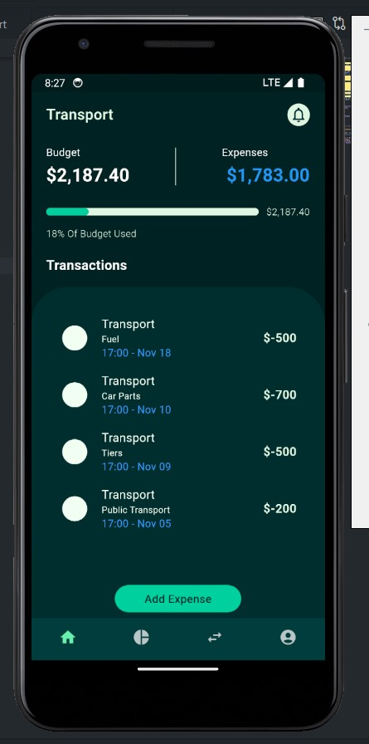

Adjustable Budgeting
Users will have the option to set a monthly budget and make adjustments as needed. This flexible budgeting tool adapts to changes in income or spending priorities, giving users more control over their financial planning.

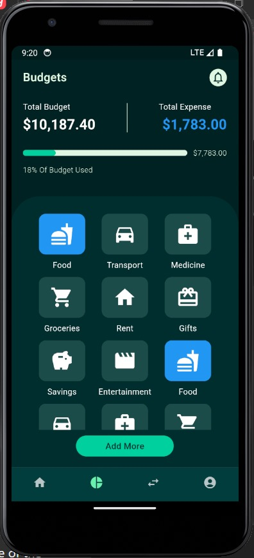
Customizable Categories
The app also enables users to create custom categories for both expenses and savings. By tailoring categories to their unique spending and saving habits, users can gain deeper insights into their financial activities and better track their goals.

4.2.2 Non-functional requirements
Performance
The system must provide real-time updates for users' financial data, ensuring that changes to income, expenses, budgets, or savings goals are reflected almost immediately after input
Compatibility
The app must work seamlessly across Android and iOS platforms, supporting devices with operating systems from Android 8.0 and iOS 12 onwards
Scalability
The app must handle many concurrent users without any degradation in performance, ensuring a smooth experience even during peak usage times
Data Integrity
The app must prevent data loss by using secure, redundant storage systems and performing regular automated backups every 24 hours.

4.2.3 Hardware & Software Requirements
Recommended hardware specifications:
- Machine with GPU for accelerated computations
- RAM: 2GB or higher
- Internal Storage: 4GB or higher
- Operating system: Android 8 or iOS 12 Upwards

5.0 SYSTEM IMPLEMENTATION, TESTING & VALIDATION

5.1 System Design
In the system design phase, we carefully integrated the outlined requirements into a cohesive architecture, ensuring optimal performance and usability. The design leverages advanced technologies to provide accurate financial tracking, budgeting, and savings goal management, delivering a seamless experience for users to efficiently manage their finances.

5.2 Architectural Design
At the heart of our system lies a robust modular architecture designed to manage personal finances efficiently. We adopted a structured approach with distinct components for user management, financial data processing, budget and savings tracking, and notification generation. This modular design ensures flexibility, ease of maintenance, and the ability to introduce future enhancements or updates seamlessly.
The app is built using Dart and Flutter, leveraging Flutter's widget-based architecture to create a highly interactive and visually appealing user interface. Key components include dynamic forms for user input, data storage and retrieval mechanisms, and real-time updates to ensure the user has an accurate financial overview. Additionally, notifications and visual elements like progress bars and graphical reports are integrated to provide an intuitive user experience. This architecture is designed to be scalable, user-friendly, and capable of adapting to evolving financial management needs.
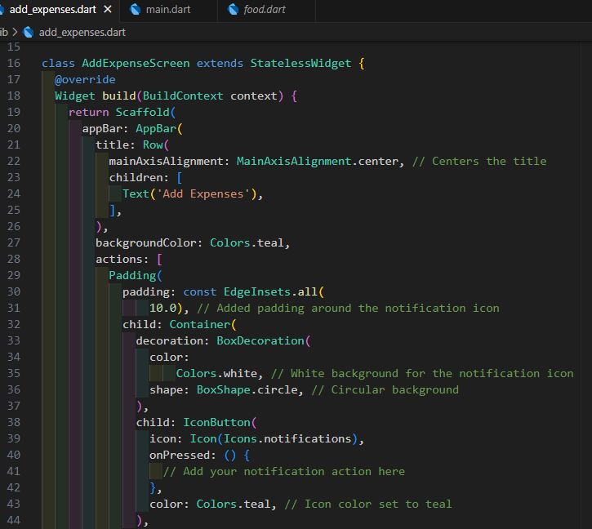

5.3 Interface Design
The user interface is designed with simplicity and functionality in mind, enabling users to interact seamlessly with the app. Users can input financial details, such as income, expenses, and savings goals, as well as set budgets and create custom categories. Visualizations, such as progress bars for savings goals and charts showing spending patterns, provide users with valuable insights at a glance. Figures in this section illustrate the interface for entering financial details, managing budgets, and tracking savings progress effectively.

6.0 SUMMARY, CONCLUSIONS AND RECOMMENDATIONS

6.1 Summary
Our mobile-based personal finance assistant app is designed to help users manage their budgets, track expenses, and achieve savings goals effectively. Throughout the development process, we employed an iterative and user-centric approach, ensuring the system was intuitive and easy to use. The app successfully allows users to create and monitor budgets, track spending, set and track savings goals, and receive timely notifications. Although the app does not offer real-time updates on every aspect, it provides a solid platform for users to gain insights into their financial status and make informed decisions.

6.2 Conclusion
This project has allowed us to apply theoretical knowledge in a practical context, addressing real-world challenges in personal finance management. The app effectively empowers users to take control of their financial well-being, providing tools for budgeting, savings tracking, and expense management. While it may not offer all the advanced features of larger, more complex financial tools, it provides users with the core functionalities they need to stay on top of their finances. The system demonstrates our ability to create a robust financial management tool that is both user-friendly and adaptable to users' changing financial needs.

6.3 Recommendations
For future improvements, we recommend integrating real-time data synchronization, so users can get instant updates on their financial progress. Enhancing the app’s predictive capabilities, such as forecasting future expenses or suggesting savings strategies, would also add value for users. Incorporating user feedback and consulting with financial experts will further refine the app’s features and performance. Lastly, expanding the app's accessibility by ensuring compatibility with additional platforms and enhancing its scalability will make it a more versatile tool for managing finances in a variety of settings.

6.4 References
World Bank. (2020). Kenya Economic Update: Navigating the Pandemic. World Bank Group.
Financial Sector Deepening (FSD) Kenya. (2019). 2019 FinAccess Household Survey. https://fsdkenya.org/publication/finaccess2019/
Communications Authority of Kenya. (2020). Fourth Quarter Sector Statistics Report for the Financial Year 2019/2020 (April-June 2020). https://ca.go.ke/
Suri, T., & Jack, W. (2016). The long-run poverty and gender impacts of mobile money. Science, 354(6317), 1288-1292.
Hasler, A., & Lusardi, A. (2017). The Gender Gap in Financial Literacy: A Global Perspective. Global Financial Literacy Excellence Center.
Munene, S., & Mutegi, L. (2019). Financial literacy and savings culture in Kenya: An empirical review of literature. Journal of Finance and Accounting, 7(4), 129-139
Statista. (2019). The Growth of Mobile Finance Applications: Trends and Statistics. Statista Industry Report, 1-10.
Thomas, J., & Mainelli, M. (2020). Mobile Apps for Financial Discipline: A Study on Budgeting and Spending Habits. Journal of Personal Finance Management, 14(2), 134-150
Kim, H., Lee, S., & Park, J. (2020). Mobile Finance Applications and Financial Awareness: An Empirical Study on App Usage Patterns. Journal of Digital Finance, 6(3), 97-111.
Wang, X., & Xiao, Y. (2019). User Experience in Mobile Finance Apps: A Critical Review. Journal of Digital Experience, 7(2), 141-159.

